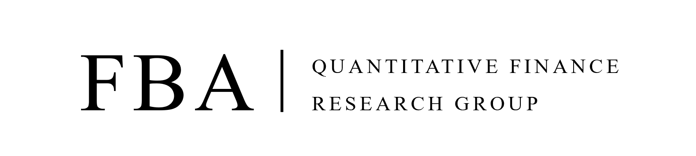
FBA Quant 2026 Winter Recruitment Application Form
(Deadline: 6:00 PM, Jan 23rd, 2026, 국문 작성)

PERSONAL DETAILS
Photo | Name
Photo | Date of Birth
Photo | Email Address
Photo | Mobile

EDUCATION
Year of Admission  - Year of Graduation | University | Major | Degree

CERTIFICATES
Name of Certificates | Issuing Organization | Year of Acquisition

AWARDS AND ACHIEVEMENTS
Name of Competition | Organization / Sponsorship | Award

WORK EXPERIENCES
Company | Department | Position | Year of Employment

OTHERS
Please list courses you have taken that are relevant to mathematics, computer science, statistics, and finance for Relevant Courses (Please specify the year you have taken)
Language proficiency
(Spoken / Written)
Programming Languages
Other Activities
Relevant Courses | Finance:  Economics:  Mathematics:  Statistics:  Programming:
ESSAY
Q. What is your career goal? (공백 제외 국문 300자/영문 130 단어 이내)
Q. What is your plan or expectation for FBA Quant? (공백 제외 국문 300자/영문 130 단어 이내)
Q. Why do you choose top 1~3 from the curriculum preference? (공백 제외 국문 300자/영문 130 단어 이내)
FBA Quant aims for a group that develops together.
Q. Do you have such experience of responsibility as a member of an organization? (공백 제외 국문 300자/영문 130 단어 이내)

FBA QUANT INTERVIEW TIMESLOT
Please mark ‘v’ on the slots that you will be available for the interview
(Please select as many slots as possible as the time slot fills up quickly.)

Technical & Behavior Interview Time Slot
- | 1/17 (Sat) | 1/18 (Sun) | 1/19 (Mon) | 1/20 (Tues) | 1/21 (Wed) | 1/22 (Thurs) | 1/23 (Fri)
08:00 - 10:00
10:00 - 12:00
12:00 - 14:00
14:00 - 16:00
16:00 - 18:00
18:00 - 20:00
20:00 - 22:00
22:00 - 24:00

Technical & Behavior Interview Time Slot
- | 1/24 (Sat) | 1/25 (Sun) | 1/26 (Mon) | 1/27 (Tues) | 1/28 (Wed) | 1/29 (Thurs) | 1/30 (Fri)
08:00 - 10:00
10:00 - 12:00
12:00 - 14:00
14:00 - 16:00
16:00 - 18:00
18:00 - 20:00
20:00 - 22:00
22:00 - 24:00

FBA QUANT CURRICULUM PREFERENCE
Please write down your preference ranking (1st ~ 4th)
Specific information about the sessions is available on the FBA Quant website (https://www.fbaquant.com)
(Preferences may not be reflected for personnel distribution. However, you can take sessions freely next semester.)
FBA Quant Curriculum
Spec 1. Fixed Income & Foreign Exchange (FF)
Spec 2. Asset Pricing (AP)
Spec 3. Market Microstructure (MM)
Spec 4. Trading-System Development (TD)

